Design Ideation

Arizona State University

EGR 314: Embedded Systems Design II

Team 302

**Generation**

Through multiple methods of brainstorming, our team came up with the following concepts, features, and ideas for our product. In **Figure 1.** and **Figure 2.** below the fruits of our brainstorming sessions can be seen in the form of multiple Jamboards.

Figure 1


**Figure 1. Jamboard 1**

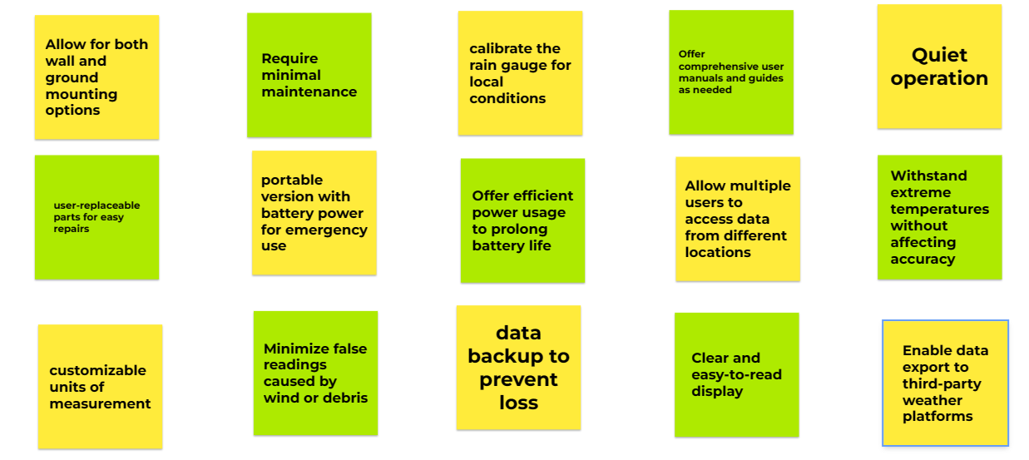

**Figure 2. Jamboard 2**

**Organizing**

We then took these ideas, concepts, and features and grouped them into categories to encompass the larger functions of the whole product. Below in **Figure 3.** the grouped ideas are color coded based on the concept they represent.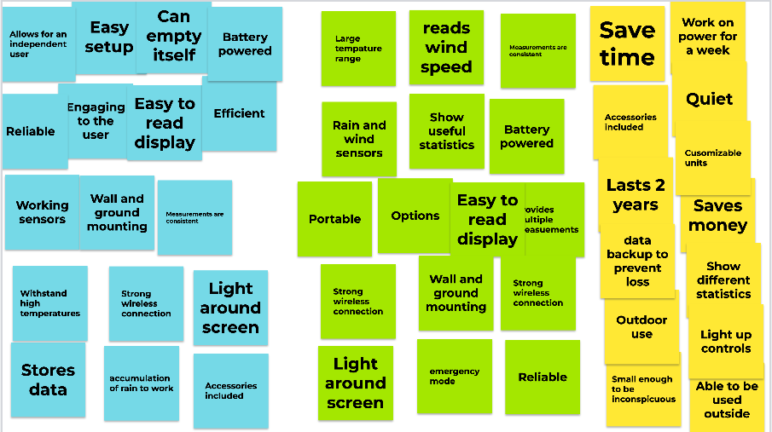

**Figure 3. Organized Ideas/Concepts,Features**

**Blue-Rain Gauge, Green-Wind Turbine, Yellow-Hygrometer**

**Concepts**

***Rain Gauge***

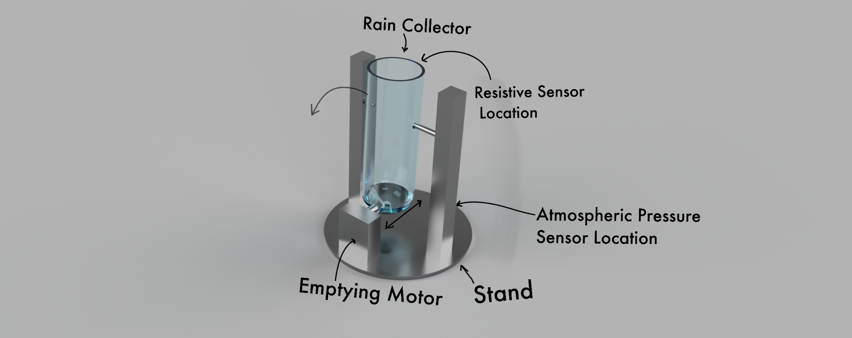

**Figure 4. Rain Gauge**

The rain gauge features a resistive sensor and an atmospheric pressure sensor to determine chances of rainfall and amount of rainfall. They collect this data and send it to the processing unit which will then upload the information to the web, making it available for the user to view from anywhere with a connection to the internet. Either on a timer or manually, the gauge will then empty itself using the motor attached to the rain collector and prepare itself to collect more data. The collector will be made of a high quality polycarbonate with a UV resistant coating to prevent discoloration, withstand extreme temperatures, and other unfavorable weather conditions. The device will have an optional backlit display if the user wants to view the data locally in their home. The smart rain gauge will also offer other options for additional weather sensors to expand its usage and ecosystem. The rain gauge will be disposable battery powered with the option for solar panel expansion along with rechargeable battery cells.

***Wind Turbine***

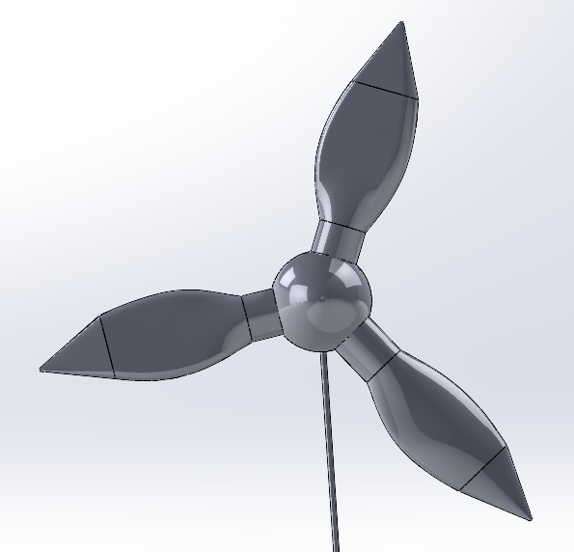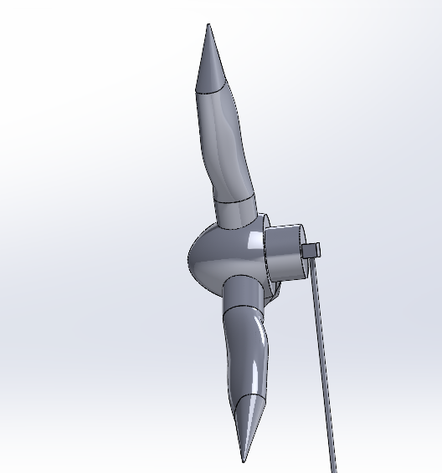

**Figure 5. Wind Turbine**

The wind turbine would be equipped with sensors to measure wind speeds and humidity, and the ability to log the data utilizing the processing unit. An alert system would utilize the readings from the sensors to notify the user if the readings are out of a specified range. A generator could take advantage of the rotational power of the rotor to produce electrical power. This could potentially generate small amounts of electricity for a variety of purposes, such as powering the system and the peripheral devices.

***Hygrometer***

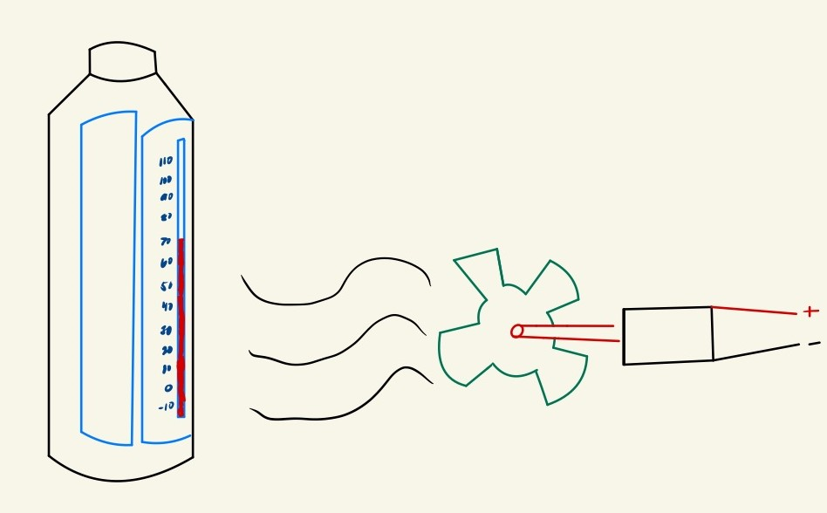

**Figure 6. Hygrometer**

The hygrometer would begin by measuring the humidity level of the air outside the bottle. Then, the thermostat would regulate the air temperature inside the bottle to a level equal to the air temperature outside the bottle. A fan would then be used to circulate the air inside the bottle. Finally, the motor would be employed to operate the lid, allowing for the exchange of air inside the bottle with the air outside. All of these function and their data would be sent to the processing unit and then broadcasted to the user.